Testimony of the PJM Power Providers Group
Before the Ohio House Energy and Natural Resources Committee
House Bill 6 - Opposed
May 22, 2019
The PJM Power Providers Group (P3 ) is a non-profit organization made up of power providers whose mission it is to promote properly designed and well-functioning competitive wholesale electricity markets in the 13-state region and the District of Columbia served by PJM Interconnection. Combined, P3 members own more than 84,000 megawatts of generation assets in Ohio and PJM, produce enough power to supply over 20 million homes and employ over 40,000 people.
P3 supports competitive generation markets and believes that consumers benefit when generators compete to serve the needs of consumers. Consumers empowered by choice will drive innovation as they force the marketplace to respond to their preferences. P3 does not support efforts that mandate that consumers purchase energy from specific technologies and P3 does not support subsidies to specific generating technologies. House Bill 6, if enacted as currently written, would force Ohio consumers to support certain generation resources while eroding many of the benefits that competitive markets have created for Ohio.
Subsidies distort competitive electricity markets by providing out of market revenue streams to specific resources while denying those benefits to others. In a market riddled with subsidies, generators are motivated to get higher subsidies than their competitors instead of seeking more efficient means of generating electricity. Over time, investment capital will leave the state as investors realize that inefficient resources will seek subsidies that undermine the investments of at-risk capital.
House Bill 6 would undermine much of the success that Ohio has enjoyed as a result of competitive electricity markets. As PJM informed this Committee, since 2017, 3,200 MW of new generation capacity has come on-line in Ohio and another 7,800 MWs is in various states of development. These new facilities have employed thousands of Ohio workers and represent several billion dollars of at-risk investment. These facilities are producing low cost electricity from Ohio’s natural resources and saving Ohio consumers of billions of dollars.
In addition to these investments in Ohio, the PJM grid enjoys robust reserve margins indicating that reliability is not in jeopardy. Fuel diversity in PJM is high as the region benefits from a diversified array of generation sources. Finally, competitive prices for generation as well as a transmission grid that is open for competition leads to of about $3 billion in saving for the entire PJM region.
House Bill 6 seeks to upend this progress by legislatively creating a fund that will provide out of market subsidies to certain, politically-favored resources. If Ohio is genuinely interested in addressing air emissions from the power sector, it has other options available that do not undermine the benefits of wholesale markets. This Committee should pursue these options instead of the flawed ones contained in House Bill 6.
However, it should be first recognized the tremendous air emissions reductions from the power sector that have occurred over the last decade in the PJM footprint. The graph below tells a powerful story about achieving environmental goals in a competitive regional electricity market. Sulphur, Nitrogen and Carbon emissions from power plants in PJM have dropped precipitously in the last decade as more efficient generating facilities (many of which are in Ohio) have replaced older less efficient units.

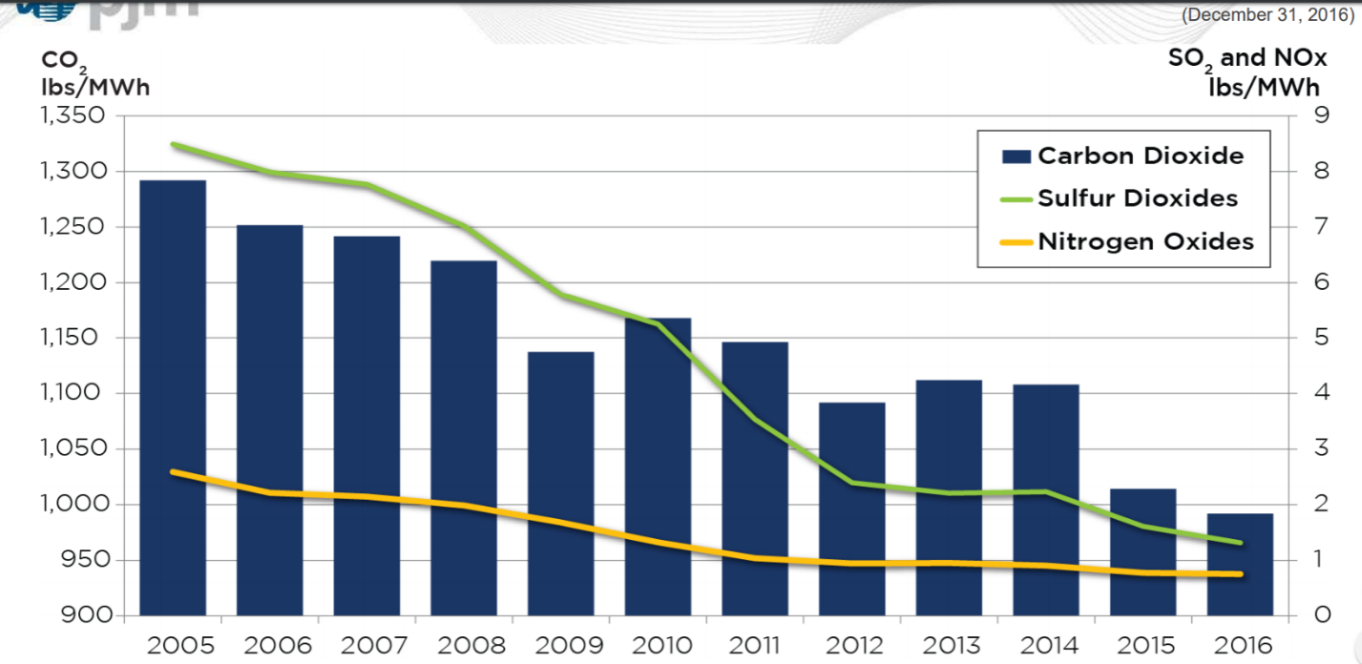

Proving that environmental progress can be achieved in a market paradigm, sulfur dioxide, nitrogen oxide and carbon dioxide emissions from power plants in PJM have dropped precipitously in the last decade, as more efficient generating facilities have replaced older less efficient units. As PJM reported in a March 2018 Emission Rates Report, the PJM system average of carbon dioxide emissions from 2013 to 2017 dropped from 1,112 pounds per megawatt-hour in 2013, to 948 in 2017. This is a 15% decrease. Similarly, sulfur dioxide emission rates dropped from 2.20 to .79 pounds per megawatt-hour, which is a 65% drop in those same four years. Further, nitrogen oxide dropped from .95 to .66 pounds per mega-watt hour, or a 31% decrease.
These declines are consistent with state and federal regulation of such pollution during that span, which was revealed through market prices and, generally, resulted in the retrofitting or retirement of coal burning facilities in favor of gas and nuclear units. While this environmental progress is significant, it is important to note that this environmental progress has been achieved within a competitive market construct in which prices fell and reliability improved. This progress was not made because Ohio selected certain resources that it wanted to subsidize, but rather through the setting of environmental goals and allowing the market, and consumers empowered with choice, to select which resources are best equipped to meet those goals.
P3 urges Ohio to pursue its clean energy goals consistent with this market structure. Ohio can achieve its energy goals through the currently existing market-based construct which would allow consumers to continue to enjoy the economic and reliability benefits of markets while knowing that environmental goals are being achieved. Ohio should clearly define the environmental goals, determine the market-consistent, regulatory means to achieve the goals, and then allow the market to determine which resources are best equipped to meet those goals. For example, instead of offering a subsidy to specific facilities that are labelled by the state as “clean air resources,” Ohio could adopt a carbon specific regulatory program that would allow all resources to compete to allow Ohio to achieve its carbon reduction goals. Many states have already done so by joining the Regional Greenhouse Gas Initiative (RGGI) which generates carbon reductions from the power sector while producing extra revenue for the state.
House Bill 6 represents a rushed attempt to redefine Ohio’s energy policy that will have broad ranging consequences for decades. Ohio is well-positioned by virtue of its location, natural resources and workforce to nurture an energy industry that will produce jobs for Ohio and low power prices for Ohio’s homes and businesses. Ohio’s electricity rates are competitive in the region and if the state is going to maintain this competitive advantage it should remain committed to competitive electricity markets. House Bill 6 is a dramatic step away from markets and toward command and control energy policies in which the state policymakers, and not consumers, are dictating the resource mix. P3 urges you to say “no” to such a regression.

The comments contained in this testimony represent the position of P3 as an organization, but not necessarily the views of any particular member with respect to any issue. For more information on P3, visit www.p3powergroup.com
https://pjm.com/-/media/committees-groups/committees/mc/20190425-somr/20190425-2018-imm-state-of-the-market-report-presentation.ashx at 15
https://www.pjm.com/about-pjm/value-proposition.aspx
See PJM 2013-2017 CO2, SO2, NOx Emission Rates, March 15, 2018, at https://www.pjm.com/-/media/library/reports-notices/special-reports/20180315-2017-emissions-report.ashx?la=en., , at page 4. “PJM 2018 Emissions Report”)
PJM 2018 Emissions Report, at page 5.
PJM 2018 Emissions Report at page 6.

